# -*- coding: utf-8 -*-

"""

Created on Tue Oct 13 13:41:45 2020

@author: sunil

"""

#-----------------HIERARICAL CLUSTERING--------------------#

import pandas as pd

import matplotlib.pyplot as plt

from sklearn.cluster import KMeans

from scipy.spatial.distance import cdist

crime= pd.read_csv("E://Excelr//excler//Hierachial and kmeans clustering//crime_data.csv")

from sklearn.preprocessing import scale

#normalize data frame

df_norm=pd.DataFrame(scale(crime.iloc[:,1:7]))

df_norm.head(5)

from scipy.cluster.hierarchy import linkage

import scipy.cluster.hierarchy as sch # for creating dendrogram

type(df_norm)

#p = np.array(df_norm) # converting into numpy array format

zz = linkage(df_norm, method="complete",metric="euclidean")

plt.figure(figsize=(15, 5));plt.title('Hierarchical Clustering Dendrogram');plt.xlabel('Index');plt.ylabel('Distance')

sch.dendrogram(

zz,

leaf_rotation=0., # rotates the x axis labels

leaf_font_size=8., # font size for the x axis labels

)

plt.show()

from sklearn.cluster import AgglomerativeClustering

h_complete=AgglomerativeClustering(n_clusters=3,linkage="complete",affinity="euclidean").fit(df_norm)

h_complete.labels_

cluster_labels=pd.Series(h_complete.labels_)

cluster_labels.value_counts()

#creating new column and assigning into it

crime['clust']=cluster_labels

crime=crime.iloc[:,:]

crime.head()

#getting aggregrate mean of each cluster

crime.groupby(crime.clust).mean()

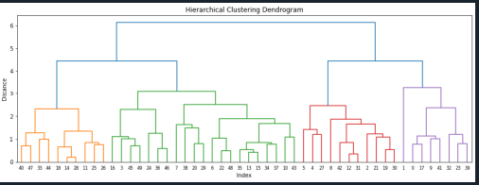  
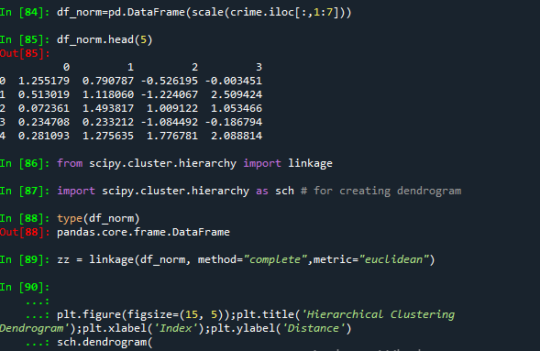

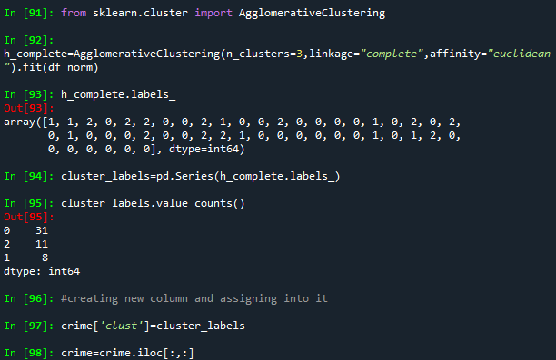

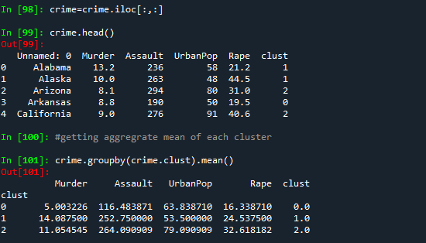

K MEANS CLUSTERING

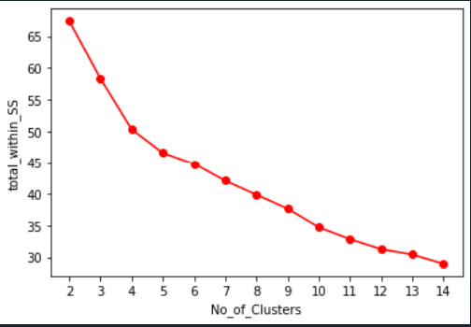

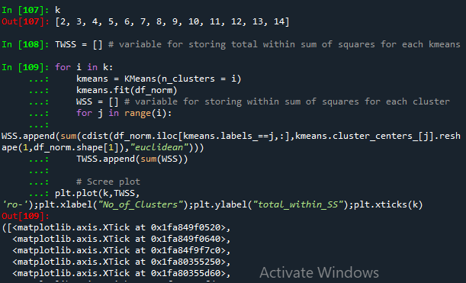

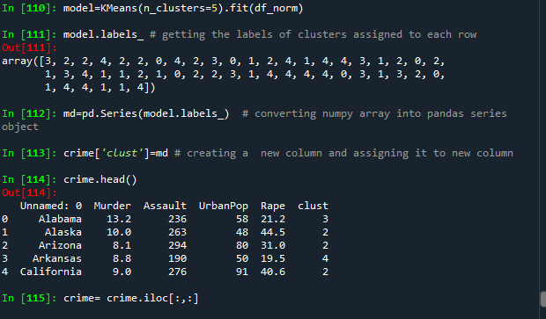

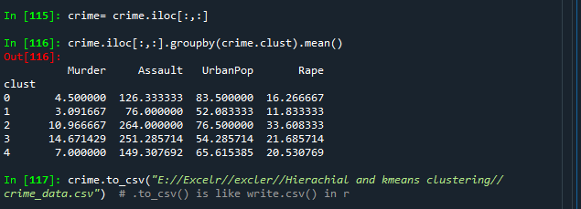

k = list(range(2,15))

k

TWSS = [] # variable for storing total within sum of squares for each kmeans

for i in k:

kmeans = KMeans(n_clusters = i)

kmeans.fit(df_norm)

WSS = [] # variable for storing within sum of squares for each cluster

for j in range(i):

WSS.append(sum(cdist(df_norm.iloc[kmeans.labels_==j,:],kmeans.cluster_centers_[j].reshape(1,df_norm.shape[1]),"euclidean")))

TWSS.append(sum(WSS))

# Scree plot

plt.plot(k,TWSS, 'ro-');plt.xlabel("No_of_Clusters");plt.ylabel("total_within_SS");plt.xticks(k)

# Selecting 5 clusters from the above scree plot which is the optimum number of clusters

model=KMeans(n_clusters=5).fit(df_norm)

model.labels_ # getting the labels of clusters assigned to each row

md=pd.Series(model.labels_) # converting numpy array into pandas series object

crime['clust']=md # creating a new column and assigning it to new column

crime.head()

crime= crime.iloc[:,:]

crime.iloc[:,:].groupby(crime.clust).mean()

crime.to_csv("E://Excelr//excler//Hierachial and kmeans clustering//crime_data.csv") # .to_csv() is like write.csv() in r